**BEE VIVA Q&A (A2_ETRX)**

**Experiment 1:**

**Q.1 What does 103 written on capacitor mean? And what type of Capacitor is it?**

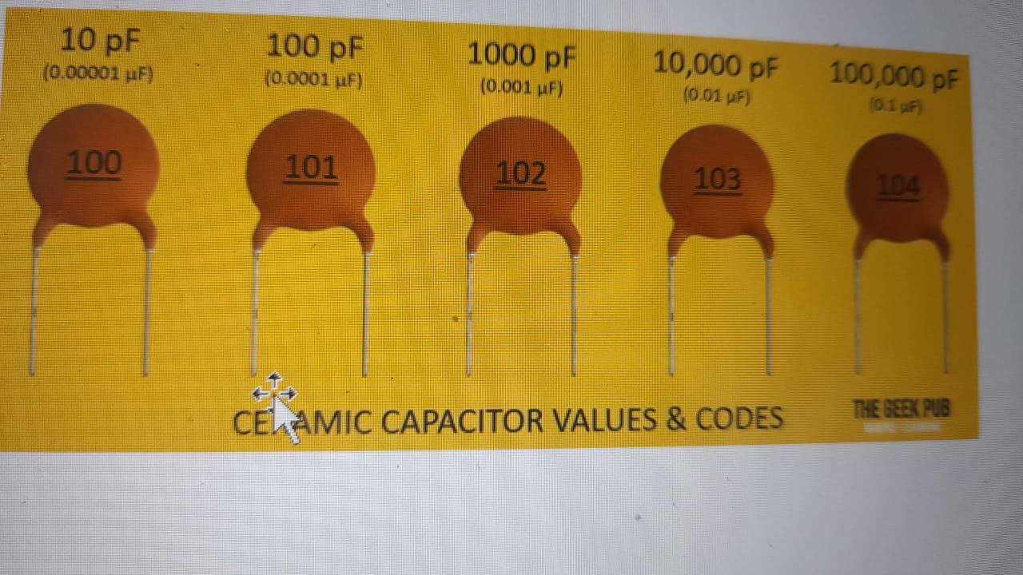

**Q.2 Distinguish between active and passive components**

| **BASIS** | **ACTIVE COMPONENTS** | **PASSIVE COMPONENT** |
| --- | --- | --- |
| Nature of source | Active components deliver power or energy to the circuit. | Passive elements utilizes power or energy in the circuit. |
| Examples | Diodes, Transistors, SCR, Integrated circuits etc. | Resistor, Capacitor, Inductor etc. |
| Function of the component | Devices which produce energy in the form of voltage or current. | Devices which stores energy in the form of voltage or current. |
| Power Gain | They are capable of providing power gain. | They are incapable of providing power gain. |
| Flow of current | Active components can control the flow of current. | Passive components cannot control the flow of the current. |
| Requirement of external source | They require an external source for the operations. | They do not require any external source for the operations. |
| Nature of energy | Active components are energy donor. | Passive components are energy acceptor. |

**Q.3 What are the types of diodes and how to identify the terminals of diode?**

A diode has two terminals. The positive side is called the anode, and the negative one is called the cathode. Physically, every diode should have some sort of indication for either the anode or cathode pin. Usually the diode will have a **line near the cathode pin**, which matches the vertical line in the diode circuit symbol.

1. LED – Light Emitting Diode

The LED pins can be identified by inspecting the LED from the top view. The one with a flattened edge is the negative pin and the straight pin is the positive pin. Usually, for new LEDs, the positive pin is the one with longer lead and the negative pin is the one with shorted lead. Or, if someone's trimmed the legs, try finding the flat edge on the LED's outer casing. The pin nearest the **flat edge** will be the negative, cathode pin.

2. LASER Diode

For practical LASER diodes like DL-3149-057, holding the curved surface towards the person holding it, the pins are numbered from 1 to 3 with the 1st pin being the cathode, the second one being the common pin and the third one being the anode.

3. PN Junction Diode:

The cathode lead is the one near a ring around the body and the other is the anode lead.

4. Photodiode:

For practical photodiodes like QSD2030F, keeping the curved surface towards the person holding the device, the shorter terminal is the cathode whereas the longer one is the anode.

**Q.4 Types of transistors, and how to identify the terminals**

#### 1. Bipolar Junction Transistor (BJT)

Transistors

Transistors may be NPN or PNP which are available in the Plastic casing or Metal Can package. In plastic casing, one side of the transistor is Flat which is the front side and the pins are arranged serially. To identify the pins, keep the front flat side facing you and count the pins as one, two etc. In most NPN transistors it will be 1 (Collector), 2 (Base) and 3 ( Emitter ). Thus CBE. But in PNP transistors, the condition will be just reversed. That is EBC.

In Metal can types, the pins are arranged circularly. Just see a Tab in the rim. In NPN type, the pin close to the Tab is Emitter, the opposite one, the Collector and the middle one,  base. In PNP type the pins are reversed. Pin close to the Tab is Collector.

But this is not a standard pin configuration. The pin arrangement may vary in some transistors.

#### 2.Field Effect Transistor(FET)

To identify a Field Effect Transistor, one should keep the curved portion facing him/her and start counting in the anti-clockwise direction. The 1st one is the source, then the gate and then the drain.

#### 3.MOSFET–Metal Oxide Semiconductor Field Effect Transistor

Usually, in some cases, the pins of MOSFET are accordingly labeled as G, S, and D denoting Gate, Source, and Drain. In some cases, it is recommended to consult the datasheet of the MOSFET. Normally making the flat side faced towards you, the pins are labeled as S, G, D starting from left to right.

#### 4.IGBT- Insulated Gate Bipolar Transistor

For a few practical IGBTs like GN2470, the raised up surface is placed towards the person holding it such that the shorter one in the middle is the cathode. The one on the left is the Gate and the one on the right is the Emitter.

#### 5. Phototransistor

For practical phototransistors like L14G2, keeping the curved surface towards the person holding it and starting from the clockwise direction, the 1st one is the collector, the second one is the emitter and the third one is the base.

**Q.4 How to differentiate between inductor and resistor**

The easiest, and most reliable, way is to look at the designator (and on a through-hole board, there is almost always a printed designator). If it says "L3", for example, it's most likely an inductor. If it says something like "R37", on the other hand, it's probably a resistor! Beyond that, resistors sometimes have a specific body color, but not always. Dipped axial-lead inductors tend to have a specific kind of 'lumpy' look because of the wire, whereas resistors are fairly regular in their midsection.

**Q.5 What is power efficiency?**

It defined as input power upon output power.

**Q.6 What is bilateral circuit?**

A bilateral circuit is a circuit that exhibits its properties equally in either direction. Furthermore, a bilateral network is one in which the relation between current and voltage do not change in either direction in the network. In summary, a bilateral circuit permits the current to flow in both directions.

**Q.7 What is the significance of resistor ratings?**

The standardization of resistor values serves several important purposes. When manufacturers produce resistors with different resistance values, these end up approximately equally spaced on a logarithmic scale. This helps the supplier to limit the number of different values that have to be produced or kept in stock. By using standard values, resistors of different manufacturers are compatible for the same design, which is favourable for the electrical engineer.

**Q.8 State the types of capacitors, and how to identify them given the value of capacitor**

1. Electrolytic Capacitor
2. Mica Capacitor
3. Paper Capacitor
4. Film Capacitor
5. Non-Polarized Capacitor
6. Ceramic Capacitor

Ceramic types of capacitors generally have a 3-digit code printed onto their body to identify their capacitance value in pico-farads. Generally, the first two digits indicate the capacitors value and the third digit indicates the number of zero's to be added.

**Experiment 2& Experiment 3:**

**Q.1 State:**

**a) Max power transfer theorem-**

In the Thevenin equivalent circuit, the maximum power transfer theorem states that “*the maximum amount of power will be dissipated in the load resistance if it is equal in value to the Thevenin or Norton source resistance of the network supplying the power*.”

In other words, the load resistance resulting in greatest power dissipation must be equal in value to the equivalent Thevenin source resistance, then RL = RS.

**b) Superposition Theorem-**

Superposition theorem states that in any linear, active, bilateral network having more than one source, the response across any element is the sum of the responses obtained from each source considered separately and all other sources are replaced by their internal resistance. The superposition theorem is used to solve the network where two or more sources are present and connected.

**c) Thevenin’s Theorem-**

Thevenin’s Theorem states that “*Any linear circuit containing several voltages and resistances can be replaced by just one single voltage in series with a single resistance connected across the load.”* In other words, it is possible to simplify any electrical circuit, no matter how complex, to an equivalent two-terminal circuit with just a single constant voltage source in series with a resistance (or impedance) connected to a load.

**d) Norton’s Theorem-**

Norton’s Theorem states that “*Any linear circuit containing several energy sources and resistances can be replaced by a single Constant Current generator in parallel with a Single Resistor*.”

**Q.2 What is the internal resistance of current and voltage source?**

Ideal voltage source-zero

Ideal current source-infinity

**Q.3 What are the applications of superposition theorem?**

The application of the superposition theorem is, we can employ only linear circuits as well as the circuit which has more supplies. Equivalent section currents and voltages algebraically included discovering what they will perform with every power supply in effect.

**Q.4 Applications of Max Power Transfer theorem-**

The theorem of [maximum power transfer](https://en.wikipedia.org/wiki/Maximum_power_transfer_theorem) can be applicable in many ways to determine the load resistance’s value that receives the maximum power from the supply and the maximum power under the state of highest power transfer.

1. Communication system.- making speaker (load resistance) equivalent to the amplifier (source resistance).
2. In automobile engines- When the resistances of the batteries and the motor are equivalent, then the highest power will be transmitted to the motor to activate the engine.

**Q.5 How to calculate IN in Norton’s Thm?**

Can be explained in own words.

**Q.6 Interpret and explain the graph of maximum power transfer**

The peak of the graph corresponds to the max power. While explaining take the cursor to the peak value, and show the coordinates. The X coordinate will be equal to Rth, hence the theorem is verified. The Y coordinate will correspond to max power.

**Q.7 If in max power transfer, we get only 50% efficiency, then why is it used in practical applications?**

This theorem works for all applications, but device will have to be selected with a lesser efficiency. It will still be used for speakers and receivers, where power is not much of a concern, but efficiency is .

**Experiment 4:**

**Q.1 Behaviour of circuit elements at various states**

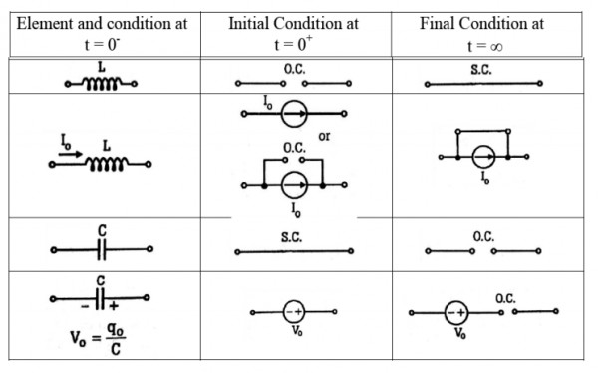

**Q.2 Why do we use SPDT Switch?**

It can serve as an on-off **switch**, depending on how the circuit is wired. Or it can serve to connect circuits to any 2 various paths that a circuit may need to **function** in. For example, a **SPDT switch** can connect to create a Ready Mode and a Standby Mode in a printer.

**Q.3 Various types and uses of switch**

Mechanical switches can be classified into different types based on several factors such as method of actuation (manual, limit and process switches), number of contacts (single contact and multi contact switches), number of poles and throws (SPST, DPDT, SPDT, etc.), operation and construction (push button, toggle, rotary, joystick, etc.), based on state (momentary and locked switches), etc.

The style usually does not affect the switch function and wiring. While switches usually are used for lights, they can be used to turn electrical current on or off for nearly any electrical device. Switches keep traffic between two devices from getting in the way of your other devices on the same network. Switches allow you to control who has access to various parts of the network. Switches allow you to monitor usage. Switches allow communication (within your network)

**Q.4 What is time constant and how to find it?**

The time required for a current turned into a circuit under a steady electromotive force to reach to (e-1)/e or 0.632 of its final strength (where e is the base of natural logarithms) specifically: the ratio of the inductance of a circuit in Henries to its resistance in ohms

The relaxation time in the discharge of a capacitor that is equal to the product of the resistance in ohms of the discharging circuit and the capacity in farads of the condenser.

**Q.5 Significance of 5T**

The time required for the capacitor to be fully charge is equivalent to about 5 time constants or 5T. Thus, the transient response or a series RC circuit is equivalent to 5 time constants. The time required for the current flowing in the LR series circuit to reach its maximum steady state value is equivalent to about 5 time constants or 5τ.

**Q.6 What does transient response of any element means?**

 A transient response is the response of a system to a change from an equilibrium or a [steady state](https://en.wikipedia.org/wiki/Steady_state_(electronics)). The transient response is the circuit’s temporary response that will die out with time. It is followed by the steady state response, which is the behaviour of the circuit a long time after an external excitation is applied.

**Q.7 Why does graph value saturate after a value?**

As it reaches it a value of 5T after which it will not show any change as the circuit reaches the equilibrium state. The transient response is the circuit’s temporary response that will die out with time.

**Q.8 Why do we open or short circuit any element in circuit?**

A practical voltage source the internal impedance is connected in series to ideal source and in current source the impedance is connected in parallel. An Ideal voltage source provides constant voltage with whatever current flowing through it. Actually it imposes its own current due to the equivalent impedance of the circuit with the other currents resulting due to other sources . Hence, as current is imposed through the voltage source, it is considered as the short circuit for finding out the effects in the circuit due to other sources. An ideal current source provides constant current with whatever voltage it develops across itself. So in the branch of the ideal current the current cannot be manipulated by any source. Hence, when writing a resultant circuit taking any other source as a reference(for superimposition) the branch of ideal current source is taken as open circuit as nothing can modify its branch current.

**Experiment 5:**

**Q.1 What is power factor in circuit?**

In electrical engineering, the power factor of an AC power system is defined as the ratio of the real power absorbed by the load to the apparent power flowing in the circuit, and is a dimensionless number in the closed interval of −1 to 1.

**Q.2 Methods to improve power factor**

To improve the power factor, capacitors in three-phase banks are connected to the system, such that the combination of the plant load and the capacitor banks presents a load to the serving utility which is nearer to unity power factor. If the magnitude of the current drawn by the capacitor is equal to the quadrature component of the load current (Iy = IL sin θ), the source will then supply only the active component of current (Ix). In that case there is a significant reduction in the current flowing through the transmission line

**Q.3 In RL or RC what are the leading or lagging components**

In R-C Circuit, the current leads the voltage by an angle phi. In R-L Circuit current lags the voltage by an angle phi.

**Q.4 What are the various types of power?**

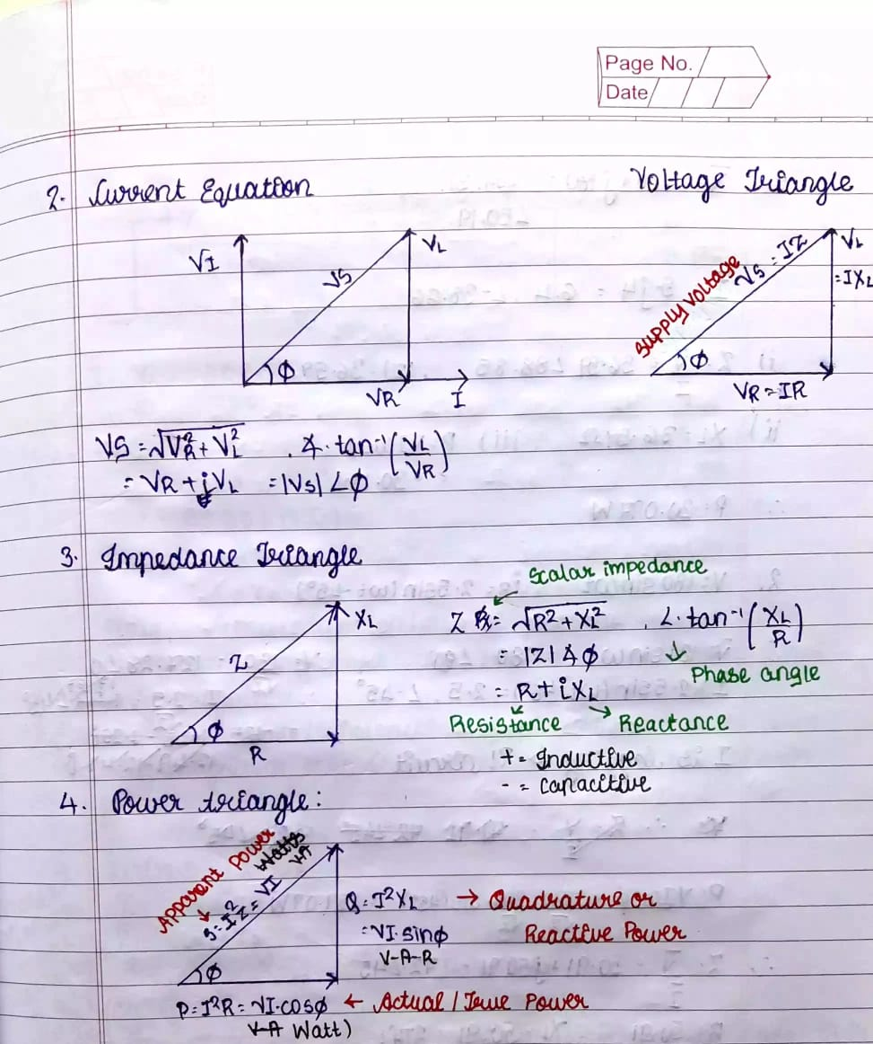

**Q.5 What is the phase difference between Va, Vb, Ic in the graph?**

The factor phi.

**Q.6 Explain the variation in the graph**

R-L Circuit:

1. When we keep R constant and vary the value of L, we can see that on decreasing the value of the resistance, there is a sharp exponential decrease in the value of L. However, even after increasing the value of the resistance to a very high value, we cannot see any major difference in the graph. It remains same as the original graph.
2. When we keep L constant and vary the value of R, the original graph has a peak at certain value and again goes on decreasing. But when we go on increasing the value of the inductance, the curve goes on becoming a gentle slope, and slowly starts becoming a straight-line graph. On decreasing the value, we go on getting a steeper graph with a prominent peak value.

R-L Circuit:

1. When we keep R constant and vary the value of C, the original graph has a peak at certain value and again goes on decreasing. But when we go on increasing the value of the inductance, the curve goes on becoming a gentle slope, and slowly starts becoming a straight-line graph. On decreasing the value, we go on getting a steeper graph with a prominent peak value.
2. When we keep C constant and vary the value of C, originally, the graph has a very steep curve. On decreasing the value of capacitance, the curve goes on becoming steeper. On the other hand, when we increase the value of capacitance , the slope goes on becoming gentler, and slowly reduces to a straight line with decreasing slope.

**Q.7 Why do we have a negative sign (-ve) ZT or RC ckt and (+ve) in RL ckt?**

Power factor lags in inductive circuit, and leads in capacitive circuit.

**Experiment 6:**

**Q.1 What does resonance mean?**

The resonant frequency of the circuit is the frequency at which the amplitude of the current is a maximum and the circuit would oscillate if not driven by a voltage source. Also power factor. i.e cos phi = 1

**Q.2 How to achieve resonance condition in :**

**a) Series-**

Resonance occurs when XL = XC and the imaginary part of the transfer function is zero. At resonance the impedance of the circuit is equal to the resistance value as Z = R.

**b) Parallel-**

Make cos phi as 1. Also with the help of phasor diagram we can find the equation

**Q.3 Type of circuit before resonance in :**

a) series- capacitive and the inductive

b) parallel- inductive and the capacitive

**Q.4 What is Q-Factor and its significance**